Lab Task 9
Task 1:
#include<iostream>
using namespace std;
class Vehicle{
protected:
string model;
double rate;
public:
Vehicle(string m,double r):model(m),rate(r){
}
virtual double getdailyrate()=0;
virtual void displaydetail()=0;
};
class Car:public Vehicle{
public:
Car(string m,double r):Vehicle(m,r){
}
double getdailyrate(){
return rate;
}
void displaydetail(){
cout<<"\nModel="<<model<<"\tRate="<<getdailyrate()<<endl;
}
};
class Bike:public Vehicle{
public:
Bike(string m,double r):Vehicle(m,r){
}
double getdailyrate(){
return rate;
}
void displaydetail(){
cout<<"\nModel="<<model<<"\tRate="<<getdailyrate()<<endl;
}
};int main(){
Car c("567MP",900000);
Bike b("HONDA87",35000);
c.displaydetail();
b.displaydetail();
}
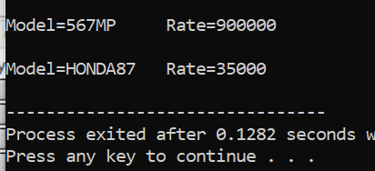
Task 2:
#include<iostream>
using namespace std;
class Device{
public:
virtual void turnOn()=0;
virtual void turnOff()=0;
virtual bool getstatus()=0;
};
class Light:public Device{
bool isON;
int brightness;
public:
void turnOn(){
isON=true;
}
void turnOff(){
isON=false;
}
bool getstatus(){
return isON;
}
};class Thermostat:public Device{
bool isON;
double temp;
public:
void turnOn(){
isON=true;
}
void turnOff(){
isON=false;
}
bool getstatus(){
return isON;
}
};int main(){
Thermostat t;
Light l;
t.turnOn();
l.turnOff();
if(t.getstatus()==1)
cout<<"Thermostat Status=On\n";
else
cout<<"Thermostat Status=Off\n";
if(l.getstatus()==1)
cout<<"Light Status=On";
else
cout<<"Light Status=Off";
}

Task 3:
#include<iostream>
using namespace std;
class Book{
string title;
string author;
string ISBN;
public:
Book(string t,string a,string i);
string gettitle();
string getauthor();
string getISBN();

}
;#include"Book.h"
using namespace std;
class Library{
Book *bb[5];
int count;
public:
Library();

void addbook(Book *b);
void removebook(Book *b);
void searchbook(Book *b);

};
#include"Library.h"
using namespace std;
Book::Book(string t,string a,string i){
title=t;
author=a;
ISBN=i;
}
Library::Library(){
count=0;
}
string Book::gettitle(){
return title;
}
string Book::getauthor(){
return author;
}
string Book::getISBN(){
return ISBN;
}
void Library::addbook(Book *b){
bb[count++]=b;
cout<<"ADDED";
}
void Library::removebook(Book *b){
for(int i=0;i<count;i++){
if(bb[i]==b)
{for(int j=i;j<count-1;j++)
{bb[i+1]=bb[i];}
cout<<"\nRemoved";
}
}count--;
}
void Library::searchbook(Book *b){
for(int i=0;i<count;i++){
if(bb[i]==b)
cout<<"\nBook found";
else
cout<<"\nBook not available";}
}
#include"Library.h";
using namespace std;
int main(){
Book b1("Peer e kamil","Umera Ahmed","7654");
Library l1;
l1.addbook(&b1);
l1.searchbook(&b1);
l1.removebook(&b1);

}
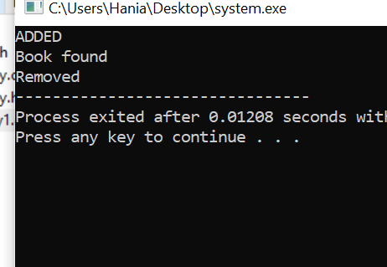
Task 4:
#include<iostream>
using namespace std;
class Payment{
public:
virtual void processpayment()=0;
};
class CreditCard:public Payment{
string cardno;
public:
CreditCard(string n):cardno(n){
}
void processpayment(){
if(cardno=="1000")
cout<<"Payment processed\n";
}
};
class DigitalWallet:public Payment{
int balance;
public:
Digita1Wallet(int b):balance(b){
}
void processpayment(){
if(balance>1000)
{balance-=500;
cout<<"Payment deducted\n";}
}
};
int main(){
DigitalWallet d(1500);
CreditCard c("1000");
c.processpayment();
d.processpayment();

Task 5:
#include<iostream>
using namespace std;
class Activity{
public:
virtual void calcCalories()=0;
};
class Running:public Activity{
double distance;
double time;
public:
Running(double d,double t):distance(d),time(t){
}
void calcCalories(){
cout<<"Calories="<<distance*time;
}
};
class Cycling:public Activity{
double speed;
double time;
public:
Cycling(double s,double t):speed(s),time(t){
}
void calcCalories(){
cout<<"\nCalories="<<speed*time;
}
};
int main(){
Running r(10,5);
Cycling c(50,8);
r.calcCalories();
c.calcCalories();}
